Connecting the AxF Format to the AxF Material Implementation in Unity

***Date: 08/06/18 (DD/MM/YY)***

At the moment, only the “SVBRDF” and “Car Paint” BRDF types are supported (not BTF nor layered then).

I will list below the variables expected by the AxF material to drive the AxF shader:

# Textures

**NOTE:** The “_sRGB” suffixed textures are only here to specify that if the texture is created as an 8-bits fomat then it should be stored as sRGB. But the AxF files usually provide floating-point values so the floating-point RGBA16F or RGBA32F formats should be preferred/expected to be fed to the shader at all times. I specify the preferred format for each texture.

**NOTE:** When a vector/color is given as the default expected value for a texture, ideally the importer should create a small 4x4 texture with that uniform color, unless there is a flag to enable or disable the texture sampling (e.g. height map or clear coat map).

**CAUTION!** Some color textures have been found to contain negative values! Max to 0!

## SVBRDF-Only Textures

* **_SVBRDF_DiffuseColorMap_sRGB** (AxF lowercase name: “**diffusecolor**”)RGB Diffuse color.  
  Usually always provided otherwise use (0,0,0,0) (black) as a default value.  
  **RGBA16F** format is advised.
* **_SVBRDF_SpecularColorMap_sRGB** (AxF lowercase name: “**specularcolor**”)RGB Specular color  
  Usually always provided otherwise use (1,1,1,1) (white) as a default value.  
  **RGBA16F** format is advised.
* **_SVBRDF_NormalMap** (AxF lowercase name: “**normal**”)Tangent-Space Normal vector with offset  
  **Warning:** The AxF format provides [-1,+1] vector values but the shader expects a classical normal with offset so you must apply the following re-ranging transform:  
  targetNormal = 0.5 * (sourceNormal + 1).  
  We should fix that and use the float values directly in the future but for the moment you can create a **RGBA16_UNORM** texture.  
  Usually always provided otherwise use (0.5,0.5,1,1) (bump) as a default value.
* **_SVBRDF_SpecularLobeMap** (AxF lowercase name: “**specularlobe**”)  
  Specular lobe in [0,1]. Also known as “roughness”.  
  Either a scalar (**R16F**) if isotropic, or a float2 (**RG16F**) if anisotropic.  
  Usually always provided otherwise use (1,1,1,1) (white) as a default value.
* **_SVBRDF_OpacityMap** (AxF lowercase name: “**opacity**”)  
  Alpha (scalar in [0,1])  
  *Never encountered.*Use 1 as a default value.  
  **R8_UNORM** format is advised.
* **_SVBRDF_FresnelMap_sRGB** (AxF lowercase name: “**fresnel**”)RGB F0 value in [0,1].  
  Usually always provided otherwise use (0,0,0,0) (black) as a default value.  
  **RGBA16F** format is advised.
* **_SVBRDF_AnisotropicRotationAngleMap** (AxF lowercase name: “**anisorotation**”)Anisotropy rotation angle.  
  **Warning:** The AxF format provides values in [-π,+π] but the shader expects a [0,1] scale so you need to apply the following re-ranging transform:  
  targetAngle = 0.5 * (1 + sourceAngle / PI)  
  We should fix that and use the float values directly in the future but for the moment you can create a **RGBA16_UNORM** texture.
* **_SVBRDF_HeightMap** (AxF lowercase name: “**height**”)  
  Height map, should be in millimeters. Rescale accordingly.  
  *Never encountered.*  
  **R16F** format advised.

## Car-Paint-Only Textures

* **_CarPaint_BRDFColorMap_sRGB** (AxF lowercase name: “**brdfcolors**”)RGB BRDF color.  
  Usually always provided otherwise use (1,1,1,1) (white) as a default value.  
  **RGBA16F** format is advised.
* **_CarPaint_BTFFlakesMap_sRGB** (AxF lowercase name: “**btfflakes**”)  
  RGB Flakes color.  
  **Warning:** This is a Texture2DArray where as many slices as the “depth” dimension indicates, also AxF provides all mip levels for the array, which must also be used otherwise very nasty aliasing would occur.  
  **RGBA16F** format is advised.  
  If not provided then use (0,0,0,0) (black) as a default value.
* **_CarPaint_thetaFI_sliceLUTMap** (doesn’t exist in AxF, must be created manually)  
  This is a custom texture created from the TYPE_INT_ARRAY property named “**thetaFI_sliceLUT**”.  
  The texture is expected to be at least the amount of entries in the INT_ARRAY. The advised format is **R8_UNORM** and the values in the INT_ARRAY *must be divided by 255.0f*.  
  In the future, we should create a **R8_UINT** texture directly to avoid the division by 255.

## Commmon Textures

Although ill-prefixed “SVBRDF”, the clear coat textures are valid for both BRDF types…

* **_SVBRDF_ClearCoatColorMap_sRGB** (AxF lowercase name: “**clearcoatcolor**”)  
  RGB Clear coat color  
  Usually provided if property “cc_no_refraction” is *not* found or set to 0, otherwise use (1,1,1,1) (white) as a default value.  
  **RGBA16F** format is advised.
* **_SVBRDF_ClearCoatNormalMap** (AxF lowercase name: “**clearcoatnormal**”)  
  Tangent-Space clear coat Normal vector with offset  
  **Warning:** The AxF format provides [-1,+1] vector values but the shader expects a classical normal with offset so you must apply the following re-ranging transform:  
  targetNormal = 0.5 * (sourceNormal + 1).  
  We should fix that and use the float values directly in the future but for the moment you can create a **RGBA16_UNORM** texture.  
  Usually provided if property “cc_no_refraction” is *not* found or set to 0, otherwise use (0.5,0.5,1,1) (bump) as a default value.
* **_SVBRDF_ClearCoatIORMap_sRGB** (AxF lowercase name: “**clearcoatior**”)  
  Clear coat F0  
  **Warning:** The AxF format provides the IOR (Index of Refraction) in [0,∞[ range but since I only support [0,1] range, I converted the IOR into a Fresnel F0 value so at the moment you need to apply the following transform:  
  **R16F** format is advised.  
  Usually provided if property “cc_no_refraction” is *not* found or set to 0, otherwise use IOR=1.5 (F0 = 0.04)

# Vector/Scalar Values

Unless explicitly written, no variable should be exposed to the user… (unlike the current state of AxFUI.cs where many variables are exposed but for debug purpose only)

## Commmon Values

* (float) **_materialSizeU_mm**  
  size of the U range, in millimeters (currently used as UV scale factor)  
  **► Should be exposed to the user.**
* (float) **_materialSizeV_mm**  
  size of the V range, in millimeters (currently used as UV scale factor)  
  **► Should be exposed to the user.**
* (uint) **_flags**
  + Bit 0 = Anisotropic. If true, specular lobe map contains 2 channels and the _AnisotropicRotationAngleMap needs to be provided (used for **SVBRDF** only).  
    **Set to match “bIsAnisotropic” bit after calling axfGetSvbrdfSpecularModelVariant()**
  + Bit 1 = HasClearCoat. If true, the clear coat must be applied. The _ClearCoatNormalMap must be valid and contain clear coat normal data.  
    **Set if any of the clear coat textures is present (color, normal or IOR)**
  + Bit 2 = ClearCoatUseRefraction. If true, then _ClearCoatIORMap must be valid and contain clear coat IOR data.  
    **Set if property “cc_no_refraction” is *not* found or set to 0.**
  + Bit 3 = useHeightMap. If true then displacement mapping is used and _HeightMap must contain valid data.  
    **Set if a height map is present.**

## SVBRDF-Only Values

* (uint) **_SVBRDF_BRDFType**
  + Bit 0 = Diffuse Type (**set to match axfGetSvbrdfDiffuseModelRepresentation**)
    - 0 = Lambert
    - 1 = Oren-Nayar (not supported at the moment) *(not encountered)*
  + Bit 1-3 = Specular Type (**set to match axfGetSvbrdfSpecularModelRepresentation**)
    - 0 = Ward
    - 1 = Blinn-Phong (not supported at the moment) *(not encountered)*
    - 2 = Cook-Torrance (not supported at the moment) *(not encountered)*
    - 3 = GGX (not supported at the moment) *(not encountered)*
    - 4 = Phong (not supported at the moment) *(not encountered)*
* (uint) **_SVBRDF_BRDFVariants**
  + Bit 0-1 = Fresnel Variant.
    - 0 = No Fresnel 🡸 **axfGetSvbrdfSpecularModelVariant returns a flag “bHasFresnel” that can be used to set this value**
    - 1 = Dielectric (Cook-Torrance 1981) *(not encountered)*
    - 2 = Schlick (1994)
  + Bit 2-3 = Ward NDF Variant (**set to match axfGetSvbrdfSpecularModelVariant**)
    - 0 = Moroder (2010)
    - 1 = Dur (2006) (supported but *not encountered)*
    - 2 = Ward (1992) (supported but *not encountered)*
  + Bit 4-5 = Blinn-Phong Variant (**set to match axfGetSvbrdfSpecularModelVariant**)
    - 0 = Ashikmin-Shirley (2000) (not supported at the moment) *(not encountered)*
    - 1 = Blinn (1977) (not supported at the moment) *(not encountered)*
    - 2 = V-Ray (not supported at the moment) *(not encountered)*
    - 3 = Lewis (1993) (not supported at the moment) *(not encountered)*
* (float) **_SVBRDF_heightMapMax_mm**  
  Maximum height map displacement, in millimeters  
  If you can provide the height maps as a **R16F or R32F** format, then this is useless and can be set to 1

## Car-Paint-Only Values

* (float) **_CarPaint_CT_diffuse**  
  Diffuse factor, directly set from property "**CT_diffuse**".
* (float) **_CarPaint_IOR**  
  Clear coat IOR, directly set from property “**IOR**”
* (float) **_CarPaint_BRDFColorMap_Scale**Optional scale factor to the BRDFColor map.  
  If you can provide the texture “**_CarPaint_BRDFColorMap_sRGB**” as a **R16F or R32F** format, then this is useless and can be set to 1
* (float) **_CarPaint_BTFFlakesMap_Scale**  
  Optional scale factor to the BTFFlakes map.  
  If you can provide the texture “**_CarPaint_BTFFlakesMap_sRGB**” as a **R16F or R32F** format, then this is useless and can be set to 1

### Cook-Torrance Lobes Descriptors

* (uint) **_CarPaint_lobesCount**  
  Amount of valid components in the vectors below.  
  You can set it from the length of the FLOAT_ARRAY properties listed below but it’s generally always set to 3, up to 4 lobes supported.
* (float4) **_CarPaint_CT_F0s**  
  Description of multi-lobes F0 values, directly set from property “**CT_F0s**”
* (float4) **_CarPaint_CT_coeffs**Description of multi-lobes coefficients values, directly set from property “**CT_coeffs**”
* (float4) **_CarPaint_CT_spreads**  
  Description of multi-lobes spread values, directly set from property “**CT_spreads**”

### Flakes Descriptors

* (float) **_CarPaint_FlakesTiling**  
  Tiling factor for flakes, *NOT* an AxF property, default value is 10.  
  **► Should be exposed to the user.**
* (uint) **_CarPaint_maxThetaI**  
  Maximum thetaI index, directly set from property “**max_thetaI**”
* (uint) **_CarPaint_numThetaF**Amount of thetaF entries, directly set from property “**num_thetaF**”
* (uint) **_CarPaint_numThetaI**  
  Amount of thetaI entries, directly set from property “**num_thetaI**”

# Tested packages

The following packages have been successfully exported and tested in Unity:

* **AxFSvbrdf_1_0_Dir, AxFSvbrdf_1_1_Dir, AxFSvbrdfNoRefract_1_3_Dir**, containing only SVBRDF materials.

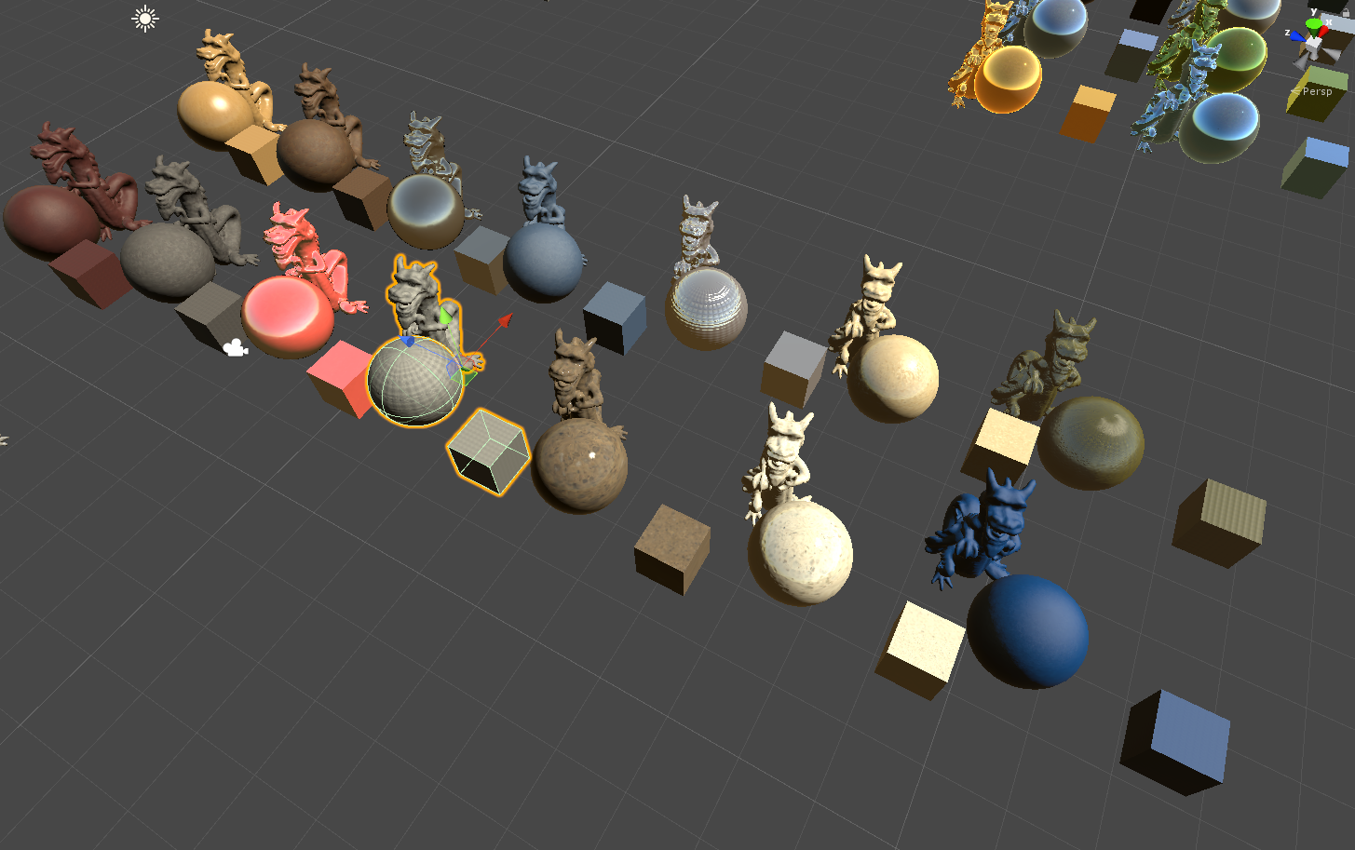

* **Volkswagen**, containing 3 SVBRDF materials + 1 car paint material

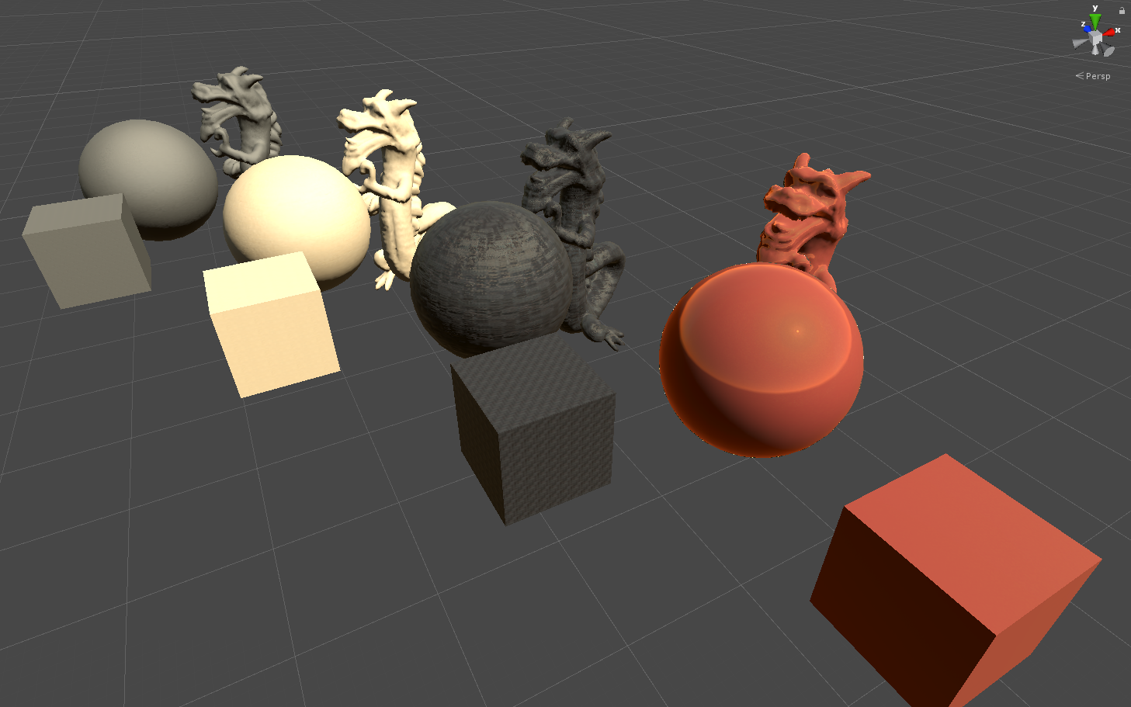

* **AxFCarPaintRefract_1_2_Dir**, containing only car paint materials

